Last Name: ZHOU First Name: YIHUA ZHOU Student ID: 83186710

1. [10pts] Find all users whose email is ‘simon.goodwin@uci.com’.

a) [6pts] Relational Algebra

σ email='simon.goodwin@uci.com' User

b) [1pt] Parse Tree

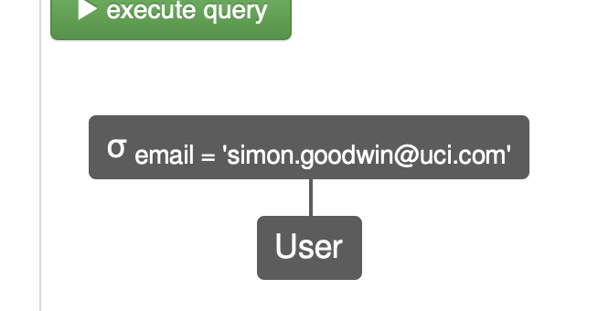

c) [3pts] Result (1 Row)

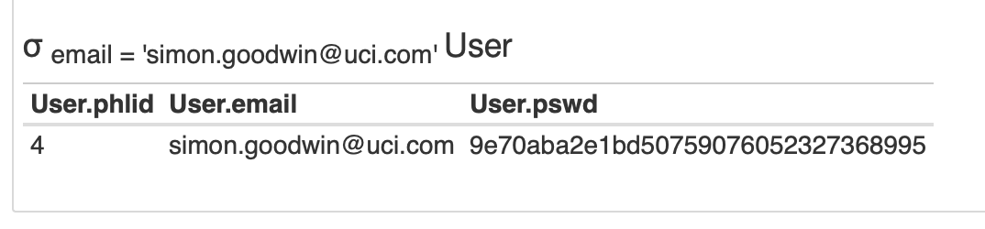

2. [10pts] List the phones of Supporters who have the role of ‘nurse’.

a) [6pts] Relational Algebra

π phone (σ role='nurse' Supporter)

b) [1pt] Parse Tree



c) [3pts] Result (2 Rows)



3. [10pts] List the name, street, and city of PHLoggers who reside in the state of ‘NC’ and are associated with an Observer.

a) [6pts] Relational Algebra

π name, address_street, address_city ((σ address_state='NC' PHLogger)⨝ Observer)

b) [1pt] Parse Tree



c) [3pts] Result (2 Rows)



4. [15pts] List the names of PHLoggers who have a thought about an interest group with topic ‘exercise’.

a) [9pts] Relational Algebra

π name (π phlid ((π iname σ topic = 'exercise' Interest)⨝ About) ⨝ PHLogger)

b) [3pt] Parse Tree



c) [3pts] Result (5 Rows)



5. [15pts] Find the phlids of PHLoggers who own an Observer of kind ‘smartphone’ and are associate with an event that doesn’t have an end date.

a) [9pts] Relational Algebra

π phlid (((π phlid σ kind = 'smartphone' Observer) ⨝ PHLogger)⨝((π phlid σ endDate = null Event) ⨝ PHLogger))

b) [3pt] Parse Tree



c) [3pts] Result (3 Rows)



6. [20pts] List the emails of users who are associated with an Observable of kind ‘bloodpressure’ as well as an Observable of kind ‘heartrate’.

a) [12pts] Relational Algebra

π email (((π phlid ((σ kind = 'bloodpressure' Observable)⨝ Observation)) ∩ (π phlid ((σ kind = 'heartrate' Observable ) ⨝ Observation))) ⨝ User)

b) [5pt] Parse Tree



c) [3pts] Result (8 Rows)



7. [20pts] List the names and emails of PHLoggers who are members of all available interest groups with the topic of ‘alcoholism’.

a) [12pts] Relational Algebra (Hint: ***Use Division!***)

Temp1 = π iname (σ topic = 'alcoholism' Interest)

Temp2 = Member ÷ Temp1

π name,email (((π phlid Temp2) ⨝ PHLogger) ⨝ ((π phlid Temp2) ⨝ User))

b) [5pt] Parse Tree

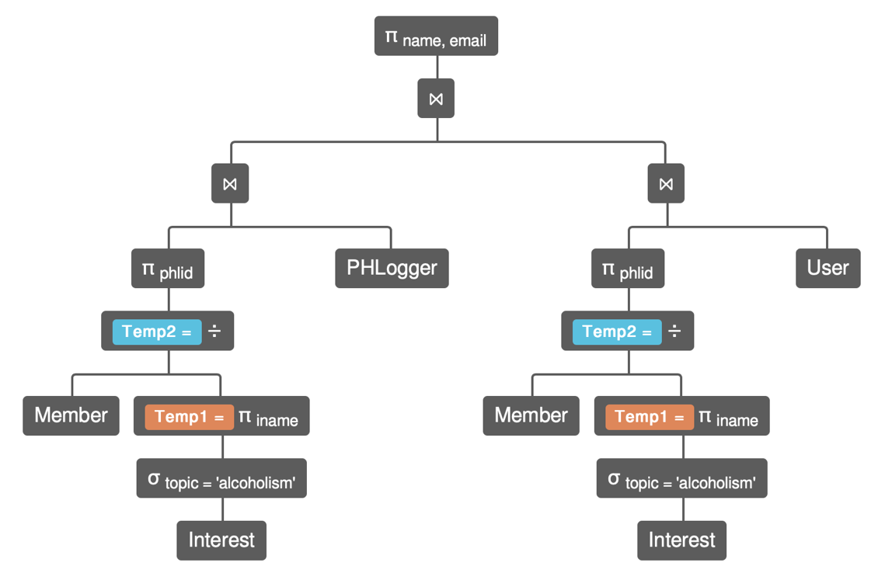

c) [3pts] Result (6 Rows)

